Conditions for Creativity | Chalk Talk
When I think of each of these cultural forces in my learning context, what comes to mind?
----
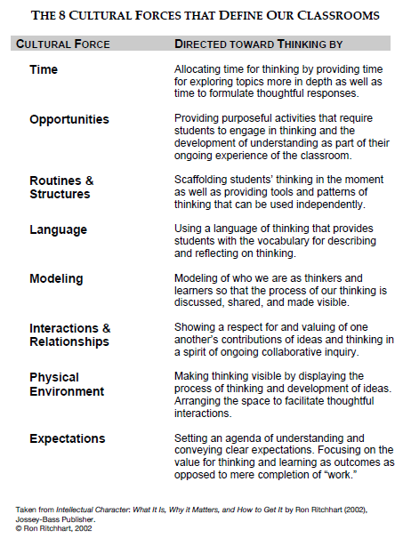
Small-Group Chalk Talk: Each group will be assigned a cultural force to investigate, Chalk Talk-style. Groups will rotate and contribute to the written discussions of at least two other forces before returning to their original force for verbal discussion and reflection.
After discussing what you notice about the evolution of the Chalk Talk of your original force, you will visit and ponder the insights and puzzles on each of the 8 Cultural Forces. For each, use the following table to record something that strikes you as powerful, perplexing, or worthy of further consideration, as well as one thing you will commit to start doing, stop doing, or do differently to harness this force in support of creativity.

Cultural Force | Something that strikes you… | Something you will commit to…
Expectations

Language

Time

Modeling

Opportunities

Routines

Interactions

Environment

